**R PROGRAMMING LAB**

**Week 1**

**Installing R and RStudio on Windows**

To install R and RStudio on windows, go through the following steps:

**Install R on windows**

**Step – 1:** Go to [CRAN R project](https://cran.r-project.org/) website.

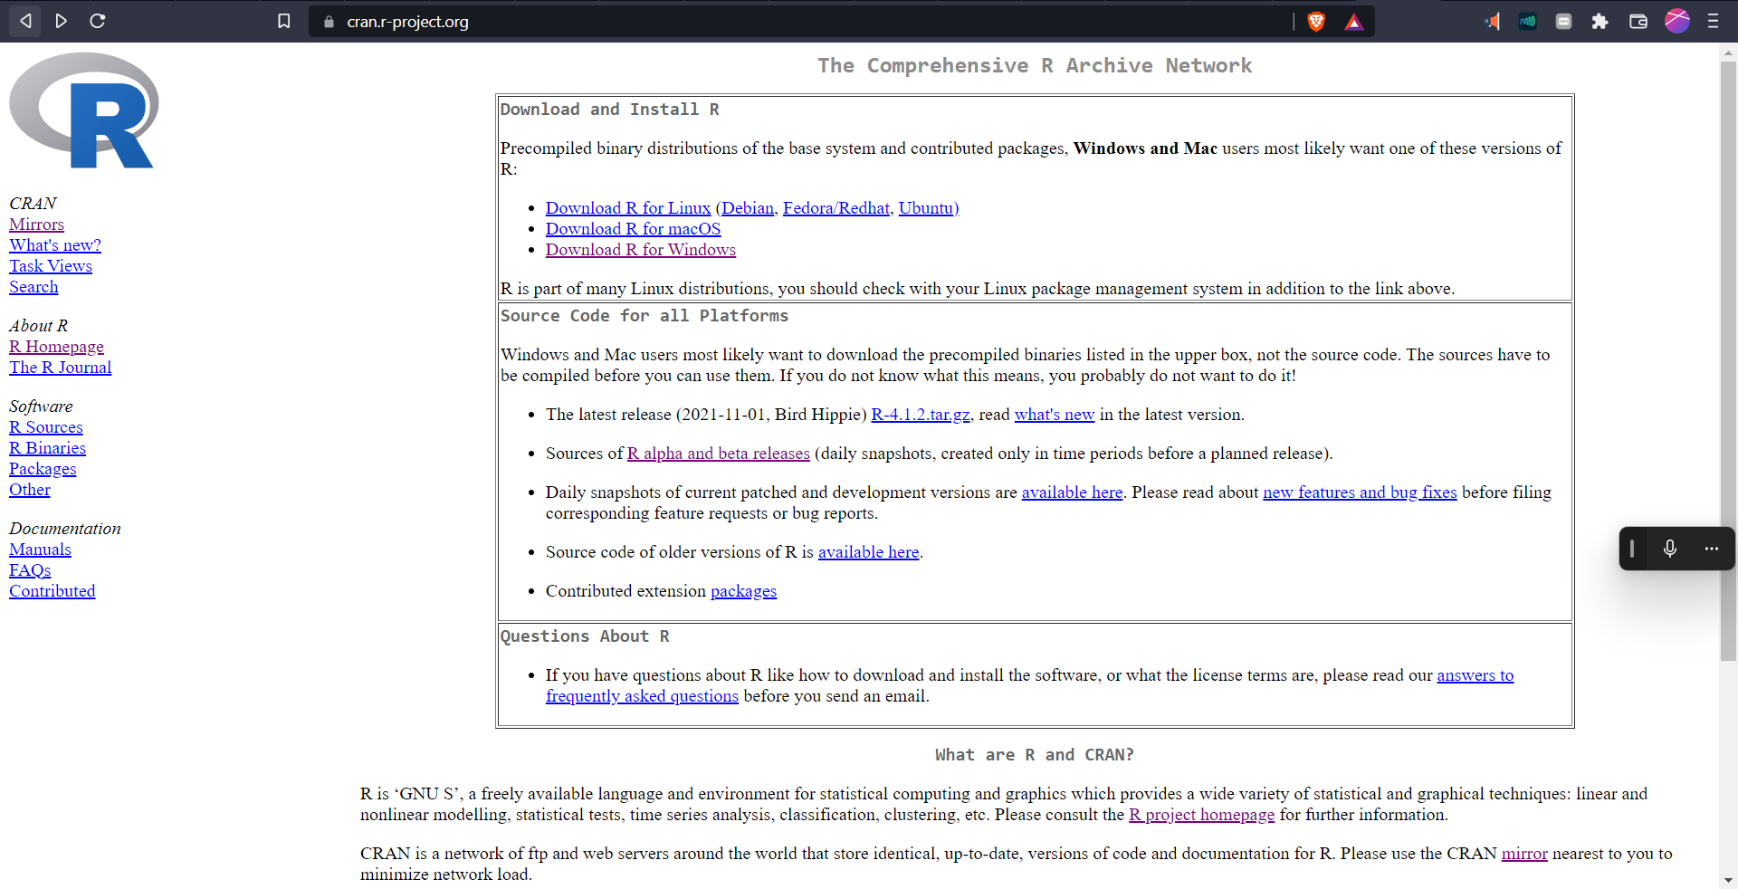

**Step – 2:** Click on the Download R for Windows link.

**Step – 3:** Click on the base subdirectory link or install R for the first time link.

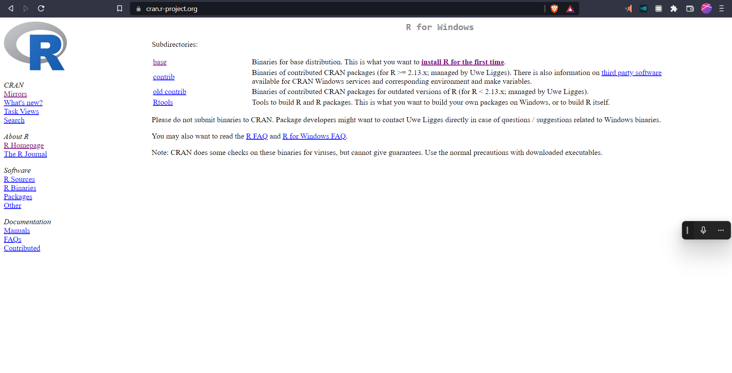

**Step – 4:** Click Download R X.X.X for Windows (X.X.X stand for the latest version of R. eg: 4.1.2) and save the executable .exe file.

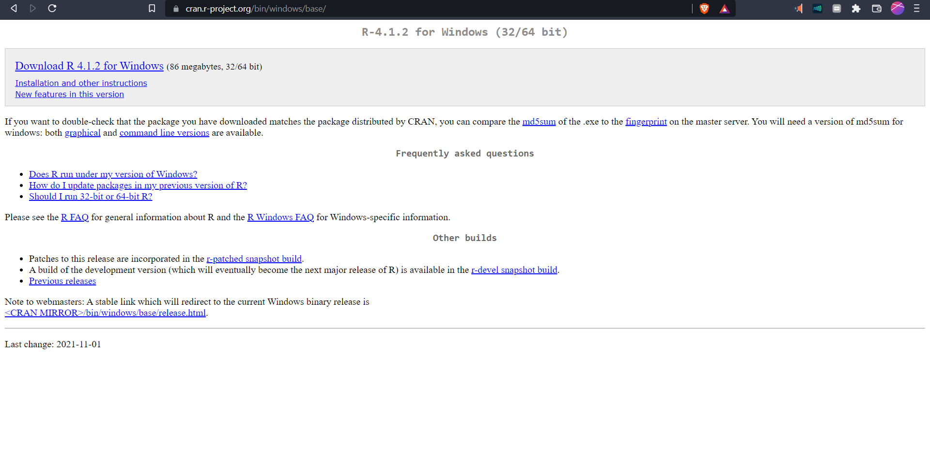

**Step – 5:** Run the .exe file and follow the installation instructions.

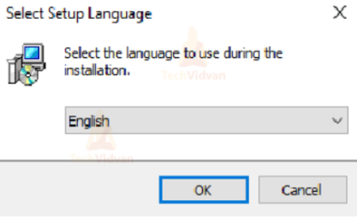

**5.b.** Read the license agreement and click Next.

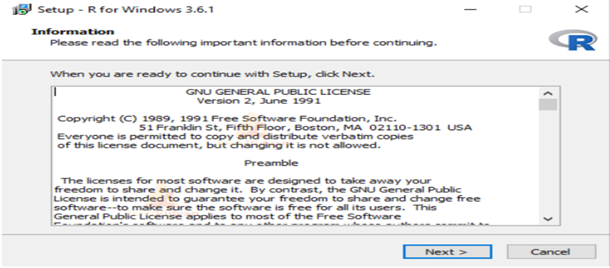

**5.c.** Select the components you wish to install (it is recommended to install all the components). Click Next.

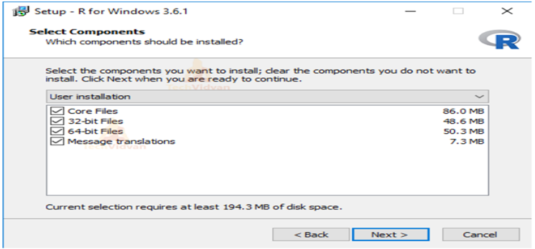

**5.d.** Enter/browse the folder/path you wish to install R into and then confirm by clicking Next.

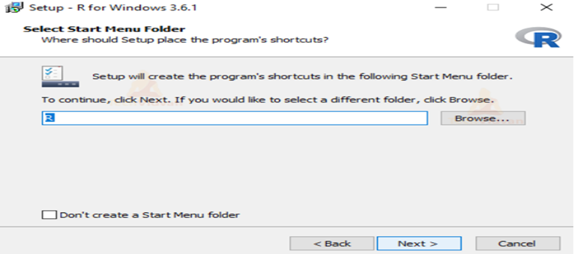

**5.e.** Select additional tasks like creating desktop shortcuts etc. then click Next.

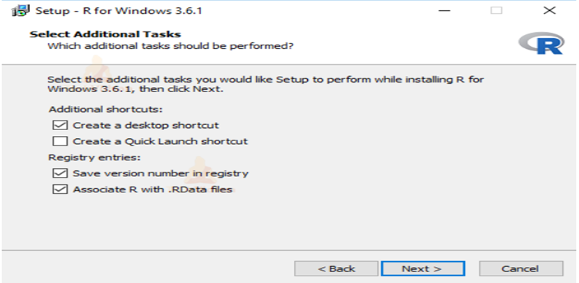

**5.f.** Wait for the installation process to complete.

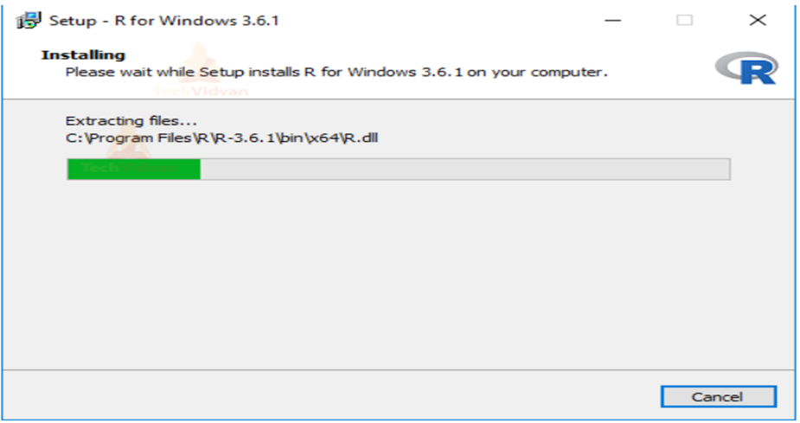

**5.g.** Click on Finish to complete the installation.

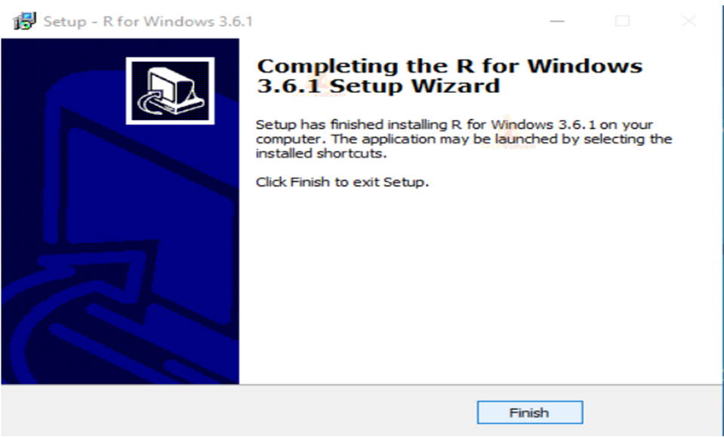

#### 

#### **Install RStudio on Windows**

**Step – 1:** With R-base installed, let’s move on to installing RStudio. To begin, go to [download RStudio](https://www.rstudio.com/ide/download) and click on the download button for RStudio desktop.



**Step – 2:** Click on the link for the windows version of RStudio and save the .exe file.

**Step – 3:** Run the .exe and follow the installation instructions.

3.a. Click Next on the welcome window.

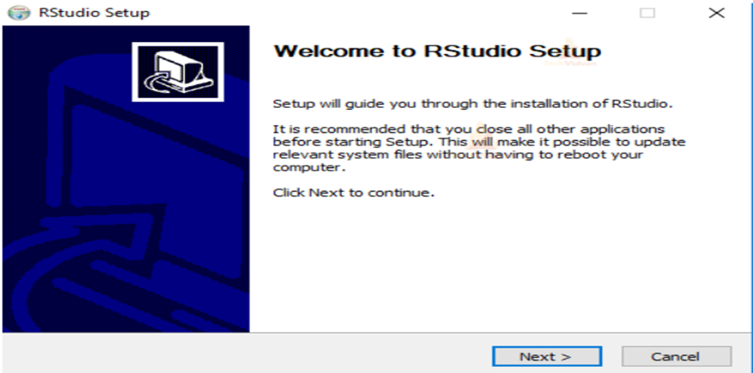

3.b. Enter/browse the path to the installation folder and click Next to proceed.

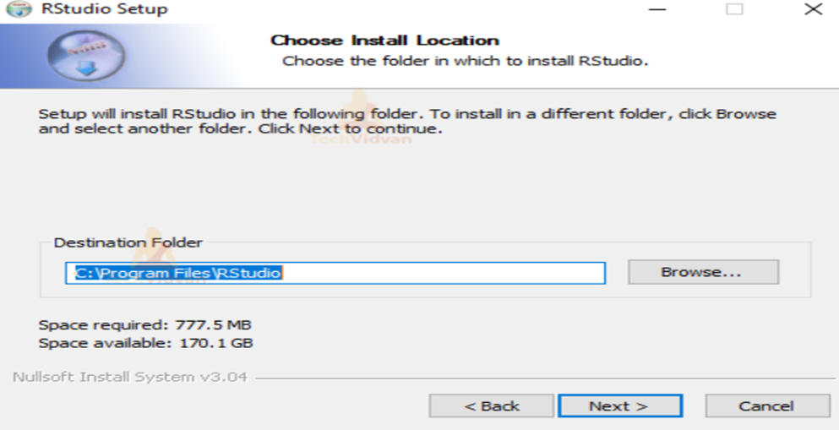

3.c. Select the folder for the start menu shortcut or click on do not create shortcuts and then click Next.

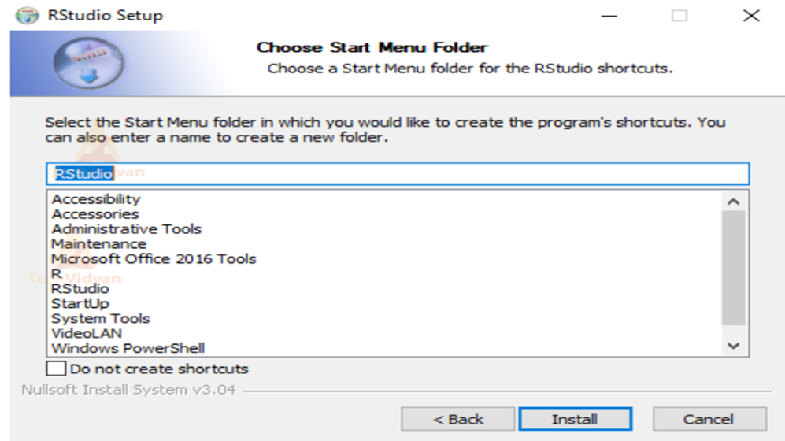

3.d. Wait for the installation process to complete.

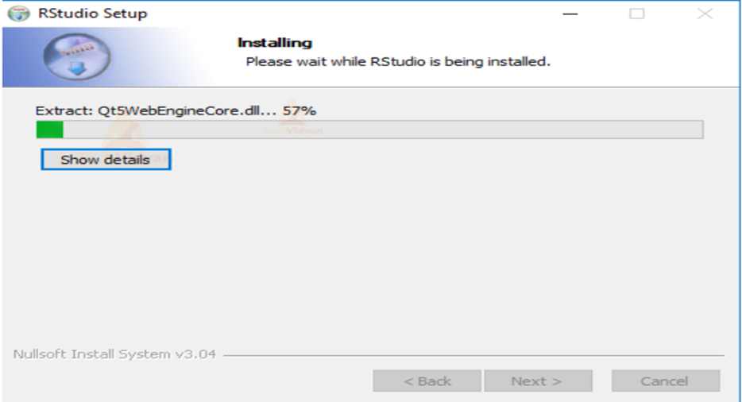

3.e. Click Finish to end the installation.

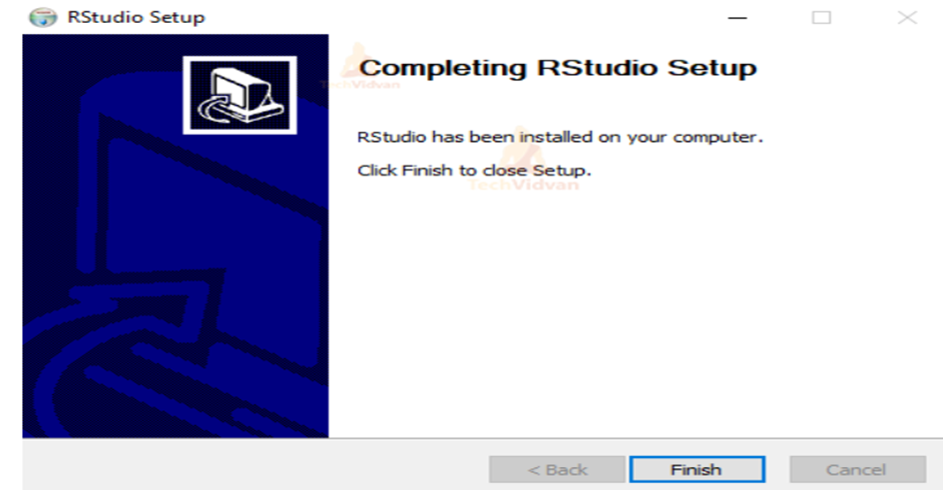

**AIM:** Write a R program to take input from the user (name and age) and display the values. Also print the version of R installation

**Code:**

name<-readline(prompt="enter username: ")  
age<- readline(prompt="enter age: ")  
print(paste("name is ",name))  
print(paste("age is ",age))

**Output:**

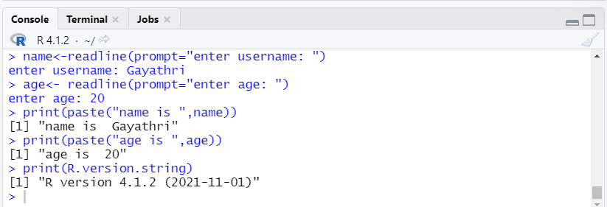

**AIM:** Write a R program to get the first 10 Fibonacci numbers

**Code:**

|  |
| --- |
| print("First 10 Fibonacci numbers") a<-0 b<-1 i=0 fib<-numeric(10) fib[1]=0 fib[2]=1 while(i<8){  c=a+b  fib[i+3]=c  a=b  b=c  i=i+1 } paste(fib) |

**Output:**

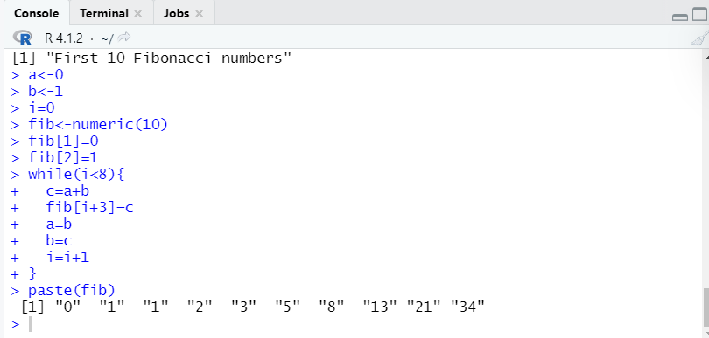

**AIM:** Write a R program to create a sequence of numbers from 20 to 50 and find the mean of numbers

**Code:**

|  |
| --- |
| print('sequence of numbers from 20 to 50: ') print(seq(20,50)) s=0 for (i in 20:50){  s=s+i   } print(paste('Mean of numbers from 20 to 60:',s/(50-20))) |

**Output:**

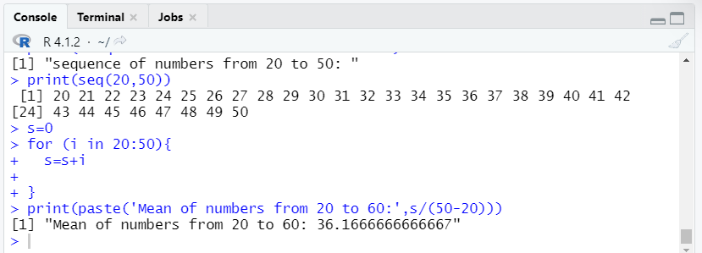

**AIM:** WARP to convert other types of object to complex type

**Code:**

|  |
| --- |
| n<-readline(prompt="enter a number: ") s=readline(prompt="enter a character: ") log=readline(prompt = "enter a logical value: ") print(class(n)) n=as.complex(n) print(class(n)) print(class(s)) s=as.complex(s) print(class(s)) print(class(log)) log=as.complex(log) print(class(log)) |

**Output:**

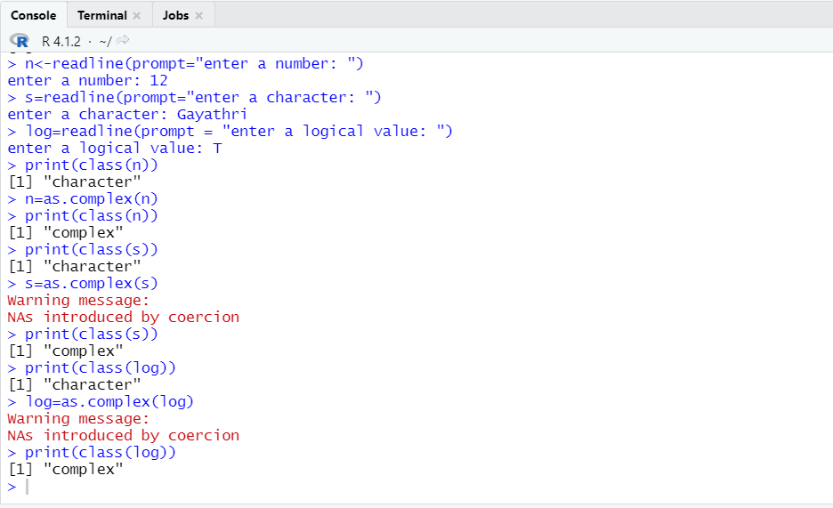

**AIM:** Write a R program to print numbers from 1 to 100 and print “AAA” for multiples of 3, print “BBBBB” for multiples of 5 and print “AAABBBBB” for multiples of both.

**Code:**

|  |
| --- |
| for(i in 1:100){  if(i%%3==0 && i%%5==0){  print("AAABBBBB")  }  else if(i%%3==0){  print("AAA")  }  else if(i%%5==0){  print("BBBBB")  }  else{  print(i)  }  } |

**Output:**

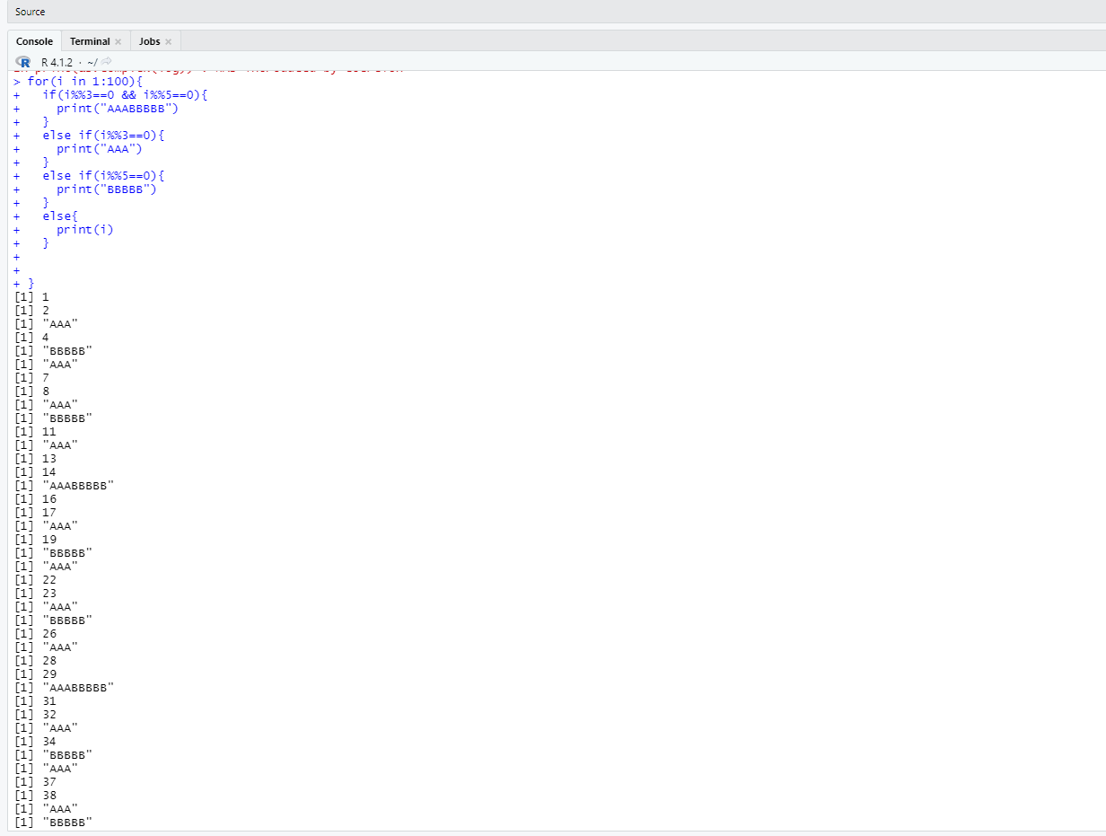 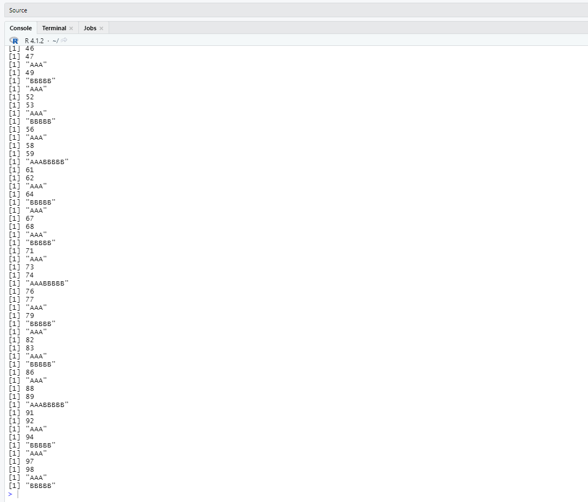

**AIM:** Write a R program to extract the first 10 english letters in lowercase and last 10 letters in upper case and extract letters between 22nd to 24th letters in uppercase.

**Code:**

|  |
| --- |
| print("First 10 letters in lower case:") print(head(letters,10)) print("Last 10 letters in upper case:") print(tail(LETTERS,10))  print("Letters between 22nd to 24th letters in upper case:") print(tail(LETTERS[22:24])) |

**Output:**

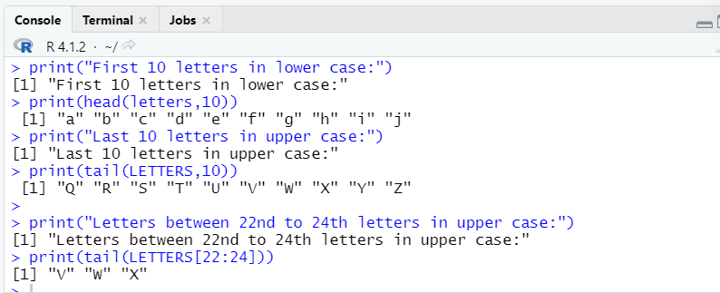

**AIM:** Write a R program to find the list of even numbers from 1 to n.

**Code:**

|  |
| --- |
| li=list() n=readline(prompt="enter a num ") for(i in 1:n){  if(i%%2==0){  li=append(li,i)  } } print('List of even nos from 1 to n') paste(li) |

**Output:**

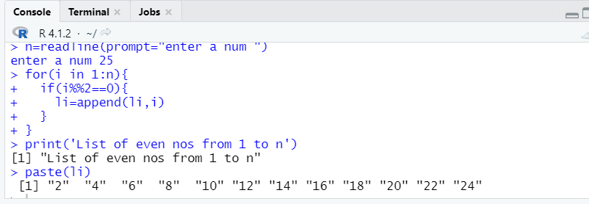

**AIM:** Write a R program to get all prime numbers up to a given number

**Code**

|  |
| --- |
| print('prime numbers up to a given number,n') n=readline(prompt = "enter a num ") for(i in 2:n){  c=0  for(j in 3:i-1){  #print(j)  #print(paste(i,i%%j,j))  if(i%%j==0){  c=c+1  #print(c)  break  }  }  if(c==0){  print(i)  } } |

**Output:**

